Business case

Project II - Analysis and development project

Caspar, David, Frédéric, Stef & Lenn

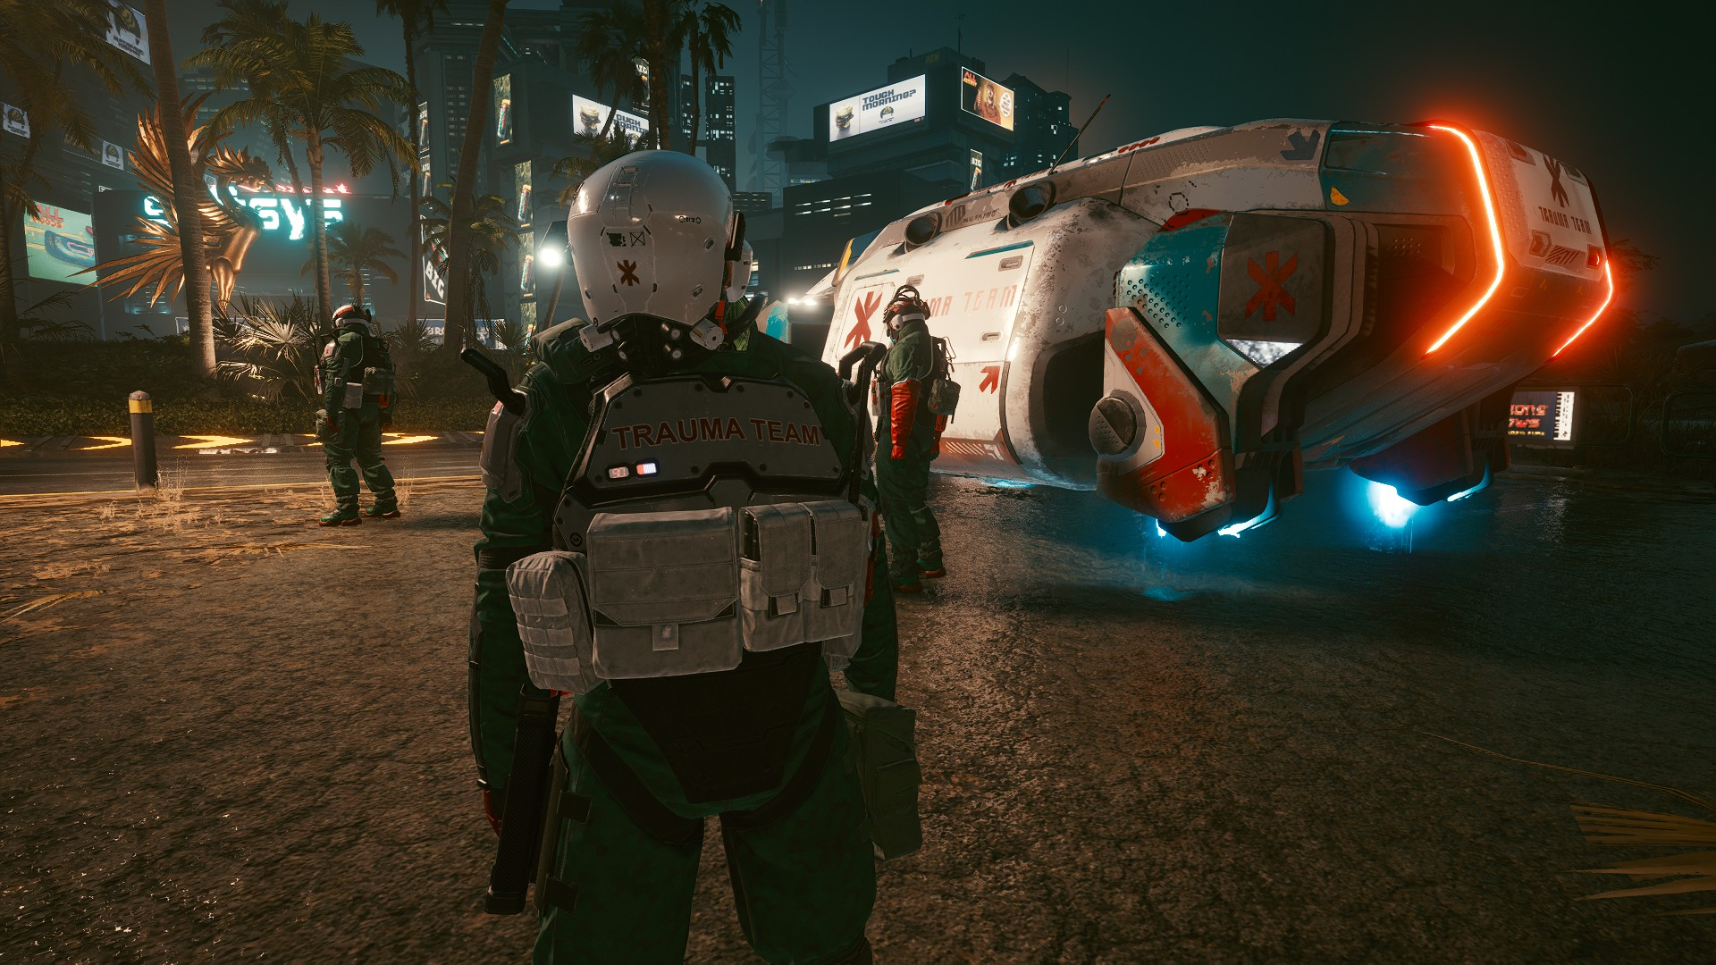

# Basic concept and approach (mission & vision)

The potentially hazardous environment of business operations in a dark dystopian Mars, and The Mars Corporate War established there means that emergency management and response planning are critical to the health and safety of the workers of any company. So that’s where our service comes into place. We will provide a service to help people in critical situations with any medical needs.

#### comment: how you’ll include all of the items specified in chapter 5 -> maybe add some more info about which api’s were gonna use.

We are M.A.R.S. (Mars Active Response System). Our domain is based on IoT and Industrial Security solutions. We provide 24/7 emergency aerial vehicle dispatch with a reflex always-ready pilot, armed safety experts, and military-trained paramedics.

A client's health is monitored by a device we put on them, and if a client takes a turn for the worse, an aerial vehicle squad receives their GPS signal and arrives on the scene in minutes. Reaction time and additional perks are dependent on the client's insurance package.

We were inspired by the game Cyberpunk 2077. The setting of this ‘triple A’ game is similar to ours. It also takes place in a dystopian world, where there is an ongoing corpo war. Where people get extracted in critical situations by an AV (Aerial Vehicle). The personnel is also military equipped and will shoot if a violent conflict happens. We really like this concept so we decided to base our service on this.

#### comment: business case diagram

# Requirements

## 2.1 Functional Requirements

* Marketing campaign: Marketing and Advertising
* Payment system: Receive payments from clients
* Monitoring vitals of clients
* Locating and navigation system: Locating/navigating clients or hospitals
* Medical and military equipment: Stabilizing clients and extracting them
* Landing or delivery area: Delivering client to hospital

## 2.2 Non-Functional Requirements

* Mobile, portable and easy to distribute marketing campaign
  + Greater reach
* Secure, fast & cheap payment system
  + Cheap (no big fees for payment processing)
* Accurate, fast monitoring system
  + Avoid unnecessary deployments
  + Avoid arriving too late
* Optimized navigation system, reliable navigation system
  + Shortest, fastest routes to arrive in time
* High quality, reliable medical and military equipment
  + High quality: it is not allowed to fail during an operation
  + reliable: have fallbacks for e.g.: power loss
* Easy to access landing area
  + Allow for fast and seamless delivery and departure to the hospital without delays

## 

# Marketing & sales

## 3.1 Product

### Building and Control Center

Where the actual monitoring and dispatching of recovery units is organized. Here there will be access to software and communications to easily and quickly deploy an active response team. Risk areas will be monitored and updated here in real time. A high risk area is an area where violence is likely. Extraction in a high risk area is bound to be tricky and dangerous for both our field team and our equipment. A low risk area is more likely to allow for a smooth and risk-free extraction.

### Ambulance and Extraction

Aerial vehicles with trained pilots and enough automation to reach the patients without a risk of crashing. A team that is capable of protecting, extracting and stabilizing the client in a fast and structured manner, even under pressure. Good coordination is a key feature to efficiently deliver a client to the hospital and warrant their chances of survival.

## 3.2 Price

### Subscriptions with tiers

#### Why Subscriptions?

A one-time payment would be way too expensive, and clients don’t always need lifetime protection. The ability to stop your subscription or extend it is allowing for a more flexible and financially maintainable way of ensuring your safety.

#### Why Tiers?

Not all clients will be exposed to the same level of risk. We offer tiers to allow clients to define their level of protection on a flexible and personal level. Upgrading or downgrading from or to another tier is possible.

A higher tier means a higher priority of extraction in case of multiple emergencies at the same time.

##### 

##### Which Tiers?

Silver, Gold, Platinum.

###### Silver

Most affordable insurance package, which only covers evacuations from green risk areas (residential, touristic, industrial in a non-conflict zone such as underground). Not outside domes or any of the described areas. Force will not be used in order to extract the client. This package is intended for common folk who do not expect to get into real tough trouble.

###### Gold

Premium insurance package, which covers all silver-tier perks with an added 100 km radius outside the habitat of a dome or industrial area, and priority extraction over silver clients in case of a queue. Limited use of force (less-than-lethal: tasers, rubber bullets, batons, flashbangs) to extract the client is included in this package.

This package is intended for people who have a realistic risk of critical injury in either their job or low-level conflicts.

###### Platinum

Omni-insurance package. Platinum includes extraction on any location of the planet at any time, with the highest priority. All other perks of both Silver and Gold are included. Lethal force is used if required. Additional fees might* occur for fuel and resources in extreme situations (see risk management for more information). Personalized perks are possible once discussed with the CEO.

## 3.3 Place

Our product will be sold online, and will be promoted on the orbital station (see promotion) by marketing agents.

## 3.4 Promotion

Promotion will be primarily done in two ways.

Information about our services is delivered in the space station through digital billboards. This way, it will be an eyecatcher in the busy environment. The CEOs of companies on mars are targeted this way as they are an effective way to get in contact with a company that might be interested in buying our products.

On the other hand, a more general public is targeted with ads on their devices. People can receive push notifications on their MarsOS enabled devices.

# Human Resources

* Ambulance Teams (Pilot, security specialist, senior EMT, assistant EMT)
* Control center operators
* CEO
* CFO
* Sales and marketing (sales officer) (marketing agents)
* Maintenance of assets (cars, buildings) is outsourced to reputable companies

## Ambulance Teams

A professional ambulance staff is required for a performant execution of our project. Fast extraction and efficient protection of the client and the equipment is a vital aspect of our service.

## Control center operators

The operators respond to calls and monitor vitals and location. They are the primary line of communication and information for our ambulance teams.

## CEO

The CEO manages the supervision of all operations and communicates the wishes of investors and platinum clients. He dictates the strategies and policies to follow in the company to optimize the profitability of our services.

## CFO

The CFO manages all calculations related to payrolls, investments, accountability, purchasing of assets and paying maintenance companies.

## Sales and marketing

The sales and marketing mission is to promote our services to the maximum amount of public and ensuring a high retention of current customers.

# Strategic Partners

## Group 11: Life outside the dome - Suits and protection equipment

Suits and protective equipment will be provided by this group. Location could possibly be accessed from the suit if the client is wearing it (alternatively it could be provided by group 12s chips).

## Group 12: MarSana - Lab-on-Chip implant for real life feed of health parameters.

This group will provide an API which our operators can use to analyze vitals of our clients in real time and give us a location feed for clients that are not wearing a suit.

## Group 14: Community hub - Meteorological information.

This group provides us with danger readings for zones we might have to travel through.

## Vehicle Maintenance (outsourced)

An already existing company is hired to take care of vehicle maintenance.

## Transportation of equipment from earth (outsourced)

This group will provide any medical or military resource needs. Also other goods like IT devices for example.

## Cargo tunnel access to the mining area (partner)

We need access to tunnels to extract a patient from underground to the surface.

## Hospitals to accept clients (partner)

We’ll work together with the hospitals from Mars, since we are just first aid. For actual treatment, we’ll have to drop our clients off at the hospital.

# Risk Management

## Control room failure

Redundancy of our systems. This should somewhat cover our operability in case of a electrical failure.

## Meteorological risks

Our Ambulance teams can be faced with extreme dangers like storms or space-dust rain. We will use danger alerts from group 14s API.

## Lack of capacity

In case of many simultaneous evacuation requests from the same location, with only one manned AV, we will send the manned AV plus all available AVs in automatic navigation mode. The teams will evacuate each patient to one of the automatic AVs. The order of evacuation is defined by the tiers of the clients.

## Failure of a vehicle

A vehicle could be blown up or receive an overwhelming amount of force once arrived on location. Based on the package of the client, the team will either postpone the extraction, reply with various levels of force or send more manned units.

# Financial Calculations

## 7.1 Revenue

### 7.1.1 Price

Our insurance service will have a monthly and yearly plan. We chose to opt for this strategy because some people don’t need a yearly plan if they only stay for 2 months. We also opted for 3 plans, depending on the amount of insurance and protection you’ll need.   
Our entry level plan is called “level 1” and is 500 MarsCoin every month, with a promotion of 2 free months if you buy it for a whole year.   
Our second plan, for the dare-devils and mine workers, will be called “level 2”. This plan is a bit more expensive since our radius for picking up clients is bigger and minimal amount of force could be used. To compensate on fuel and the equipment used, this plan will be priced at 750 MarsCoin per month with the same promo as “level 1”.

Our last plan is called “level 3” and is focused on high-profile clients. There is no maximum limit on the distance we’ll travel to extract these clients. These clients have the highest priority over all other tiers. There is also no limit to the amount of force used. Because of this, our price is higher than all other tiers we offer. This tier is aimed at for example CEOs of big companies and comes down to 1000 MarsCoin per month. The same offer mentioned above is valid on this tier.

### 7.1.2 Quantity per period

There are 10’000 people in a single dome. The people that work in the mines are also included in this number. This means that a dome with a lot of miners will seem a bit more empty, but that’s because they are in the mines. The families of the miners will stay in the domes.  
We assume that 9 out of 10 people will need and buy our insurance. This boils down to 90’000 subscriptions every month.

10’000 people bought service over 10 domes (People that are underground count as the same people in the domes but that means that those domes seam more empty)

5 mines in the domes -> 10 teams

5 solo domes -> 20 teams

sum up some usecases of the domes

2 ambulances per dome, for the mining domes 1 surface 1 underground.

or 1/500 people

## 7.2 Costs

### 7.2.1 Fixed costs

Since we need a headquarter to monitor our clients, the equivalent of a 911 dispatch office in America on earth. This will cost us a lot of money to buy, so we’ll opt to rent it. The rent comes down to 10’000 MarsCoin every month. Because we rent the building, maintenance is included like cleaning.  
Besides the headquarters, we need a base station in every dome to settle our field team and aerial vehicles. These will come down to 1000 MarsCoin every month. This price includes cleaning and maintenance.   
The loans of our soldiers are also a fixed cost. Since our soldiers had a high amount of training and are putting themselves at risk, we’ll pay them 2000 MarsCoin every month.

Our salesmen will need a place to stay in the orbital station while he waits for people to come in there to go to Mars. They will offer our possible clients our service so they have to be rested out before talking to them.

Since we’ll rescue people from the mines underground, we’ll need to lease an office there as well. There, we can use their cargo elevator to rescue a client to the surface and then to a hospital. This elevator is used less than a normal elevator and will extract our clients much faster than a normal elevator. The cost of the elevator will be included in the lease of the office down there. This office will come down to 500 MarsCoin per year. The price is cheaper than the bigger office because we help the workers down there. This price also includes cleaning and maintenance in the building.

To extract a heavily injured client, we’ll use a cryogenic tank. These stabilize our clients and makes sure that they don’t bleed out. We’ll have one of these in every aerial vehicle and will cost us around 1000 MarsCoin a piece.  
A company named “The Martian Sol” will provide us with details from the outside world. These will include the risk of a storm, meteor and more. Their API comes has a yearly fee of 10 MarsCoin.

Giving our clients the biosensor is done by a company already on Mars. The biosensor cost and the cost to attach them to a client will be 200 MarsCoin. Once attached, they pop up in our system and we can monitor them.

To protect our field team in the combat zone, we’ll need bulletproof and medical suits. These suits will be a modified version of another company on Mars to fit our needs. These suits will cost about 100 MarsCoin a piece and are self-repairing. The modifications done to the suits are 50 MarsCoins extra on top of the 100 MarsCoin mentioned above.

### 7.2.2 Variable costs

One of our variable costs is fuel for our aerial vehicles. This depends on the distance of our flight to get our client. This expense is combated by our tiers, since the farther you go from the domes, the higher your tier should be. The higher the tier, the more the client has to pay. The cost per kilometer is relatively cheap, going by 1 MarsCoin/kilometer.  
Our second variable cost is our military equipment, like bullets, armoured suits… Those cost money if we have to use them in combat. This is again combated by our tiers, since the cheapest option doesn’t include any form of force. The more a client pays, the more expensive gear we’ll use. The cheap equipment used to extract someone from the gold tier is around 50 MarsCoin if thoroughly used. The more expensive equipment used to extract someone from the platinum package is around 100 MarsCoin if everything has been used.

The cost to lease an ambulance will be around 750 MarsCoin a month for every ambulance. The price includes cleaning and fixing the ambulance every week. This means it will be sort of a “trade in”-system, we give them the aerial vehicle of last week and they give us a “new” one while they fix the old one.

## 7.3 Break-even analysis

Break-even analysis

* based on your summary of revenue and costs
  + how much do you have to sell to be profitable
  + when will you be profitable

The amount where the revenue is the same as the costs

Total Revenue = Total Costs

Price x Quantity = Total constant costs + Total variable costs

Price x Quantity = Total constant costs + (Varbiable cost for every entitiy x Quantity)

Price x Quantity - (Varbiable cost for every entitiy x Quantity) = Total constant costs

Quantity x (Price - Varbiable cost for every entitiy) = Total constant costs

Quantity = Total constant costs / (Product - Varbiable cost for every entitiy)

## 7.4 Finance mix

Finance mix

* Probably we don’t have enough savings to do the necessary investments, so you have to look for external money. Explain our financial mix